INDIA GENERAL ELECTIONS RESULT ANALYSIS 2024
TOTAL SAET
SELECT COUNT(parliament_constituency) AS TOTAL_SEAT
FROM statewise_results
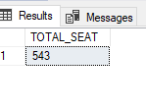
WHAT IS THE TOTAL NUMBER OF SEATS AVAILABLE FOR ELECTIONS IN EACH STATE
SELECT s.state AS Each_State,
COUNT(cr.parliament_constituency) AS Availabe_Seat
FROM constituencywise_results cr
INNER JOIN
statewise_results sr ON cr.parliament_constituency = sr.parliament_constituency
INNER JOIN
states s ON sr.state_id = s.state_id
GROUP BY s.state
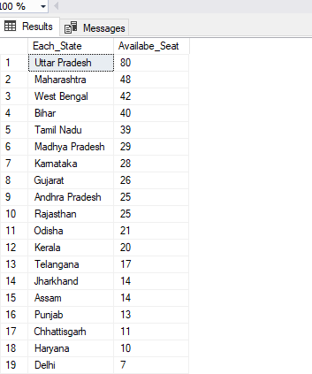
ORDER BY Availabe_Seat DESC
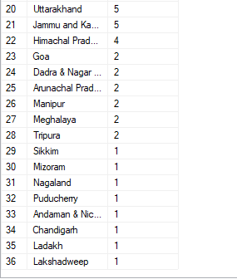
ADD NEW COLUMN FIELD IN TABLE PARTYWISE_RESULTS TO GET THE PARTY ALLIANZ AS NDA, I.N.D.I.A AND OTHER
NDA
ALTER TABLE partywise_results
ADD Party_coalition varchar(50)

UPDATE partywise_results
SET Party_coalition = 'NDA'
WHERE Party IN
( 'Bharatiya Janata Party - BJP',
'Telugu Desam - TDP',
'Janata Dal (United) - JD(U)',
'Shiv Sena - SHS',
'AJSU Party - AJSUP',
'Apna Dal (Soneylal) - ADAL',
'Asom Gana Parishad - AGP',
'Hindustani Awam Morcha (Secular) - HAMS',
'Janasena Party - JnP',
'Janata Dal (Secular) - JD(S)',
'Lok Janshakti Party(Ram Vilas) - LJPRV',
'Nationalist Congress Party - NCP',
'Rashtriya Lok Dal - RLD',
'Sikkim Krantikari Morcha - SKM' )

I.N.D.I.A

UPDATE partywise_results
set party_coalition = 'I.N.D.I.A'
WHERE PARTY IN
( 'Indian National Congress - INC',
'Aam Aadmi Party - AAAP',
'All India Trinamool Congress - AITC',
'Bharat Adivasi Party - BHRTADVSIP',
'Communist Party of India (Marxist) - CPI(M)',
'Communist Party of India (Marxist-Leninist) (Liberation) - CPI(ML)(L)',
'Communist Party of India - CPI',
'Dravida Munnetra Kazhagam - DMK',
'Indian Union Muslim League - IUML',
'Nat`Jammu & Kashmir National Conference - JKN',
'Jharkhand Mukti Morcha - JMM',
'Jammu & Kashmir National Conference - JKN',
'Kerala Congress - KEC',
'Marumalarchi Dravida Munnetra Kazhagam - MDMK',
'Nationalist Congress Party Sharadchandra Pawar - NCPSP',
'Rashtriya Janata Dal - RJD',
'Rashtriya Loktantrik Party - RLTP',
'Revolutionary Socialist Party - RSP',
'Samajwadi Party - SP',
'Shiv Sena (Uddhav Balasaheb Thackrey) - SHSUBT',
'Viduthalai Chiruthaigal Katchi - VCK'
)
OTHERS
UPDATE partywise_results
SET party_coalition = 'OTHER'
WHERE party_coalition IS NULL

TOTAL SEATS WON BY NDA ALLIANS
SELECT party as party_name,
won as Total_seat_won,
party_coalition
FROM partywise_results
where party_coalition = 'NDA'
order by won desc
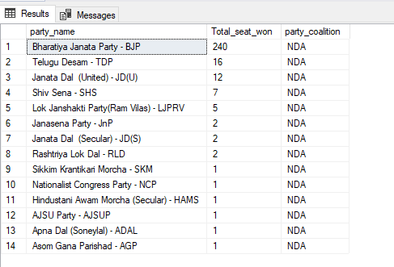
TOTAL SEATS WON BY I.N.D.I.A. ALLIANS
SELECT party as Party_name,
won as Total_seat_won,
party_coalition
FROM partywise_results
where party_coalition = 'I.N.D.I.A'
order by Total_seat_won desc
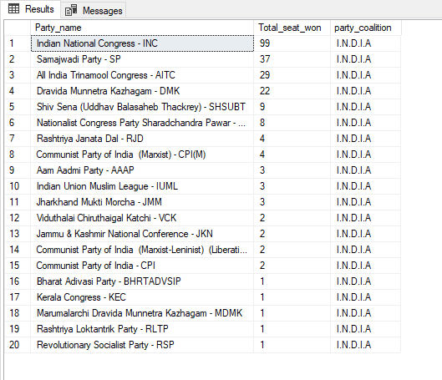
WHICH PARTY ALLIANCE (NDA, I.N.D.I.A, OR OTHER) WON THE MOST SEATS ACROSS ALL STATES
select party_coalition as Party_Name,
sum(won) as Total_seat_won
from partywise_results
group by party_coalition
order by Total_seat_won desc
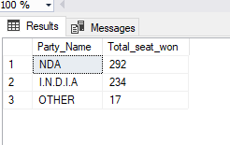
WINNING CANDIDATE'S NAME, THEIR PARTY NAME, TOTAL VOTES, AND THE MARGIN OF VICTORY FOR A SPECIFIC STATE AND CONSTITUENCY
select
cr.winning_candidate,
pr.party,
cr.Total_votes,
cr.Margin,
s.state,
cr.constituency_name
from constituencywise_results cr
join
partywise_results pr ON cr.Party_ID = pr.Party_ID
join
statewise_results sr ON cr.Parliament_Constituency = sr.Parliament_Constituency
join
states s ON sr.State_id = s.state_id
where s.state = 'Gujarat' and cr.constituency_name = 'BHAVNAGAR'
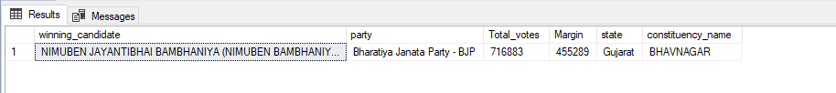
WHAT IS THE DISTRIBUTION OF EVM VOTES VERSUS POSTAL VOTES FOR CANDIDATES IN A SPECIFIC CONSTITUENCY
select
cd.EVM_votes,
cd.Postal_votes,
cr.constituency_name
from constituencywise_details cd
join
constituencywise_results cr on cd.Constituency_ID = cr.Constituency_ID
where cr.constituency_name = 'ALLAHABAD'

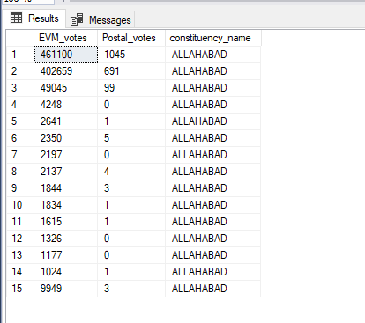

WHICH PARTIES WON THE MOST SEATS IN THE STATE, AND HOW MANY SEATS DID EACH PARTY WIN
select
pr.party,
count(pr.won) as seat_won
from partywise_results pr
join
constituencywise_results cr on pr.party_id = cr.party_id
join
statewise_results sr on cr.Parliament_Constituency = sr.Parliament_Constituency
group by pr.party
order by count(pr.won) desc
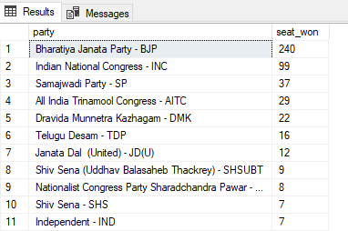
WHAT IS THE TOTAL NUMBER OF SEATS WON BY EACH PARTY ALLIANCE (NDA, I.N.D.I.A, AND OTHER) IN EACH STATE FOR THE INDIA ELECTIONS 2024
select
s.state as State_name,
sum(case when pr.party_coalition = 'NDA' then 1 else 0 end) as NDA_seat_won,
sum(case when pr.party_coalition = 'OTHERS' then 1 else 0 end) as OTHERS_seat_won,
sum(case when pr.party_coalition = 'I.N.D.I.A' then 1 else 0 end) as INDIA_seat_won
from partywise_results pr
join constituencywise_results cr on pr.party_id = cr.party_id
join statewise_results sr on cr.parliament_constituency = sr.parliament_constituency
join states s on sr.state_id = s.state_id
group by s.state
order by s.state
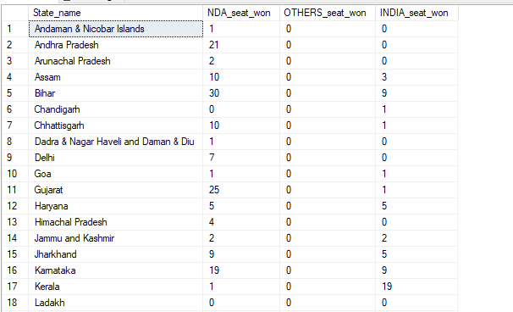
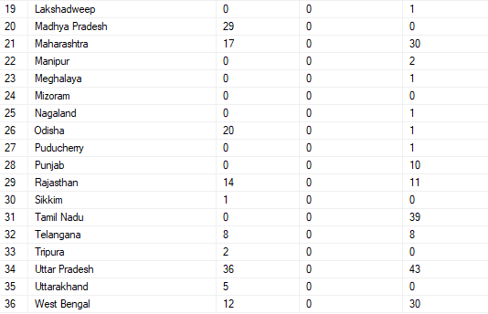

WHICH CANDIDATE RECEIVED THE HIGHEST NUMBER OF EVM VOTES IN EACH CONSTITUENCY (TOP 10)
select top 10
cd.candidate as candidate_name,
cd.EVM_Votes as highest_EVM_Votes,
cr.constituency_name
from constituencywise_details cd
inner join
constituencywise_results cr on cd.Constituency_ID = cr.Constituency_ID
where cd.EVM_Votes = (
select max(cd1.EVM_Votes)
from constituencywise_details cd1
WHERE cd1.Constituency_ID = cd.Constituency_ID
)
order by cd.EVM_votes desc
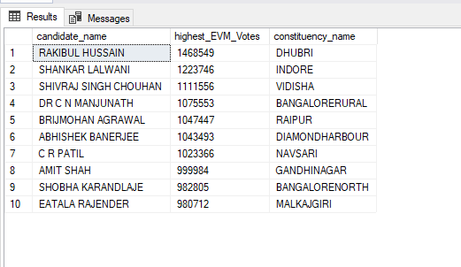
WHICH CANDIDATE WON AND WHICH CANDIDATE WAS THE RUNNER-UP IN EACH CONSTITUENCY OF STATE FOR THE 2024 ELECTIONS
WITH RankedCandidates AS (
SELECT
cd.Constituency_ID,
cd.Candidate,
cd.Party,
cd.EVM_Votes,
cd.Postal_Votes,
cd.EVM_Votes + cd.Postal_Votes AS Total_Votes,
ROW_NUMBER() OVER (PARTITION BY cd.Constituency_ID ORDER BY cd.EVM_Votes + cd.Postal_Votes DESC) AS VoteRank
FROM
constituencywise_details cd
JOIN
constituencywise_results cr ON cd.Constituency_ID = cr.Constituency_ID
JOIN
statewise_results sr ON cr.Parliament_Constituency = sr.Parliament_Constituency
JOIN
states s ON sr.State_ID = s.State_ID
WHERE
s.State = 'Manipur'
)

SELECT
cr.Constituency_Name,
MAX(CASE WHEN rc.VoteRank = 1 THEN rc.Candidate END) AS Winning_Candidate,
MAX(CASE WHEN rc.VoteRank = 2 THEN rc.Candidate END) AS Runnerup_Candidate
FROM
RankedCandidates rc
JOIN
constituencywise_results cr ON rc.Constituency_ID = cr.Constituency_ID
GROUP BY
cr.Constituency_Name
ORDER BY
cr.Constituency_Name
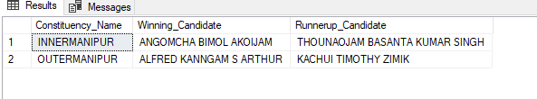

FOR THE STATE OF MAHARASHTRA, WHAT ARE THE TOTAL NUMBER OF SEATS, TOTAL NUMBER OF CANDIDATES, TOTAL NUMBER OF PARTIES, TOTAL VOTES (INCLUDING EVM AND POSTAL), AND THE BREAKDOWN OF EVM AND POSTAL VOTES
select
count(distinct cr.Constituency_ID) AS Total_Seats,
count(distinct cd.Candidate) AS Total_Candidates,
count(distinct p.Party) AS Total_Parties,
sum(cd.EVM_Votes + cd.Postal_Votes) AS Total_Votes,
sum(cd.EVM_Votes) AS Total_EVM_Votes,
sum(cd.Postal_Votes) AS Total_Postal_Votes
from
constituencywise_results cr
JOIN
constituencywise_details cd on cr.Constituency_ID = cd.Constituency_ID
JOIN
statewise_results sr on cr.Parliament_Constituency = sr.Parliament_Constituency
JOIN
states s on sr.State_ID = s.State_ID
JOIN
partywise_results p ON cr.Party_ID = p.Party_ID
WHERE
s.State = 'Maharashtra'
